Final Report to ACSI for Award 04-08 and Addendums 1 & 2
Prepared by Mark Sabaj
Complete hard-copy with receipts sent to Griffin Sheehy on 5 May 2005

Project title: The South American Transcontinental Catfish Expedition:

Peruvian Leg

Name of applicants: Hernán Ortega, Chief & Curator, Ichthyology, Museo de Historia Natural, UNMSM (MUSM) & Profesor Principal, Chairman of Hidrobiologia y Pesqueria Department, Facultad de Ciencias Biologicas, Universidad Nacional Mayor de San Marcos, Lima
Norma J. Salcedo, Doctoral Student, Texas Tech University, Lubbock
Mark H. Sabaj, Collection Manager, Academy of Natural Sciences of Philadlephia & Co-Principal Investigator, All Catfish Species Inventory

Email addresses: hortega@terra.com.pe
norma.salcedo@ttu.edu
sabaj@acnatsci.org

Phone numbers: Hernán Ortega: (511) 471-0117
Norma J. Salcedo: (806) 742-1335
Mark H. Sabaj: (215) 299-1026

Fax numbers: Hernán Ortega: (511) 265-6819
Mark H. Sabaj: (215) 405-5080

Mailing addresses: Hernán Ortega
Departamento de Ictiologia
Museo de Historia Natural
Aptdo. 14-0434
Lima 14, PERU

Norma J. Salcedo

Department of Biological Sciences
Texas Tech University
Lubbock, TX 79409-3131

Mark H. Sabaj
Academy of Natural Sciences, Ichthyology
1900 Ben Franklin Parkway
Philadelphia, PA 19103

Total Amount Received from UF & Expended (see Appendix 1):

$21,990 USD (to MHS via Award 04-08)
$2,500 USD (to L.M. Sousa via Addendum 1)
$957.73 (to B. Sanchez Rengifo via Addendum 2)

In August 2003 Hernán Ortega, Norma Salcedo and Mark Sabaj met at the Museo de Historia Natural de la Universidad Nacional Mayor de San Marcos, (MUSM) in Lima to plan the Peruvian leg of the Trans-Continental Catfish Expedition. The Brazilian leg of the trans-continental expedition would be conducted by a team of Brazilian ichthyologists led by Roberto Reis of the Museu de Ciências e Tecnologia, Pontifícia Universidade Católica do Rio Grande do Sul in Porto Alegre, Brasil.

The co-leaders of the Peruvian leg decided upon a route across southern Perú that would be both safe and afford ample opportunities to collect catfishes in remote and poorly sampled areas (Fig. 1). The route they agreed upon began in Lima (Perú's capital) and would pass through a total of 5 departmental capitals and 13 provincial capitals en route to the frontier town of Iñapari. Iñapari lies on the right bank of the Río Acre at a point where the borders of three countries (Perú, Brasil and Bolivia) meet. The Brazilian team would finish at Assis Brasíl on the opposite bank. Unfortunately, timing conflicts did not permit a union of the two teams in the Río Acre. Nevertheless, both teams successfully completed their respective missions, sampling fishes across central South America (between S6 and 16 degrees latitude) in a near Trans-Continental transect.

Four additional ichthyologists joined Hernán, Norma and Mark in Lima: Blanca Rengifo Sánchez and Roberto Quispe Chuquihuamaní (MUSM), Lesley Sales de Souza (Auburn Univ.) and Lúcia Rapp Py-Daniel (Instituto Nacional de Pesquisas da Amazônia, Manaus). Norma recruited two drivers, Elliott López Pacheco and Miguel Arizoga Paquero, whose contributions to the expedition extended well beyond that of chauffeurs. Midway through the expedition Hernán, Roberto and Lúcia returned to Lima and the team received 2 fresh replacements: Mariangeles Arce (Univ. Nacional de Colombia, Bogotá) and Leandro Melo de Sousa (INPA) who would help complete the trip. No fewer than 5 countries (Brasil, Canada, Colombia, Perú and the US) were represented by the passports carried by the participants of the trans-Peruvian expedition.

Team Perú set out from Lima on July 1 and completed sampling on August 2, 2004, with a collection in the Río Acre at Iñapari. They visited a total of 62 sites (Fig. 2), 55 of which produced collections of nearly 6000 specimens. The sites fell into 5 categories according to drainage: Pacific coast (4, 629-3199 m), Apurimac (21, 1791-3999 m), Urubamba (19, 560-3989 m), Madre de Dios (17, 164-2665 m) and Purus (1, 240 m). See Table 1 for general locality data.

The expedition focused on poorly sampled mountain rivers and their smaller tributaries. The highest sampling site to yield fish was in the Río Mestizas (3999 m, TCEP 04-04) in the Pachachaca-Apurimac system. Unfortunately this fish was the introduced rainbow trout. The highest site to yield a native fish (an unknown species of trichomycterid catfish) was in the Río Mapacho (3504 m, TCEP 04-39) in the Urubamba Basin. Astroblepids were recorded at most sites (41 total), often in significant numbers, and at elevations ranging from 1791-2994 m in the Apurimac (17 sites), 560-2251 m in the Urubamba (16 sites), and 444-1108 m in the Madre de Dios (8 sites) basins. Collections from all sites yeilded catfishes representative of at least 9 families and an estimated 12-21 new or undescribed species (Table 2).

In September 2004 Norma Salcedo and Blanca Rengifo visited the Academy of Natural Sciences in Philadelphia to help Mark Sabaj sort and identify the collections. Half of the material was returned to MUSM as per regulations stipulated in the collecting permit. The remaining material is to be divided among the other participant institutions: ANSP, AUM, and INPA.

Some of the specimens already have been sent to specialists for identification and study. For example, all of the astroblepids (95 lots, 894 specimens total) were mailed to Scott Schaefer at the American Museum of Natural History. Schaefer is working on a revision of the family with a grant from the National Science Foundation.

A significant product of the expedition is the website available via the All Catfish Species Inventory homepage. The transPeru expedition website (http://silurus.acnatsci.org/ACSI/field/Peru2004/1index.html) is composed of 73 separate webpages and contains over 200 images of fishes collected during the expedition (177 images of catfishes + 30 images of other fishes, all cross-referenced to collecting sites). Nearly all of these images are of specimens with life colors and many are of species never before photographed as such. The website includes a general overview of the expedition, information on participants, general locality data for all sites visited, a map of the expedition, and hundreds of photos related to participants, fieldwork and specific collecting sites.

Mark Sabaj will present preliminary results of the transPeruvian expedition as an oral talk (co-authored by Norma Salcedo and Hernán Ortega) at the 2005 Joint Meeting of Ichthyologists and Herpetologists at the University of South Florida, Tampa.

Expenditures for the transPeru expedition totalled $29,768.80 and the entire amount of ACSI award 04-08 (including Addendums 1 and 2) was spent. Addendum 1 ($2,500) was awarded to Leandro M. Sousa (for airfare from Brazil to Peru for Leandro and Lúcia Rapp Py-Daniel). Addendum 2 ($957.73) was awarded to Blanca Sanchez Rengifo (for airfare from Lima, Peru to Philadelphia to help process the transPeru collection). All expenditures are accounted for in Appendix 1 (note that some itemized expenditures were charged separately to ANSP ACSI account 876-0000).

Table 1. Localties visited during transPeru Expedition (* fishes sampled).

month/ day | TCEP | water body (sites without fishes in italics) | elevation | latitude | longitude
7/2 | 04-01 | Rio Santuario (trib Pisco, Pacific Dr.) * | 1771 | -13 25' 46.95291'' | -75 27' 37.41366''
7/2 | 04-02 | Rio Pisco (Pacific Dr.) * | 629 | -13 39' 59.61214'' | -75 46' 17.76908''
7/4 | 04-03a | Rio San José (trib Acari, Pacific Dr.) * | 3087 | -14 36' 41.84172'' | -74 15' 55.04834''
7/4 | 04-03b | Rio San José (trib Acari, Pacific Dr.) | 3199 | -14 36' 54.86247'' | -74 15' 39.15646''
7/5 | 04-04 | Rio Mestizas (trib Chalhuanca, Ucayali Dr.) * | 3999 | -14 29' 36.09992'' | -73 15' 11.33817''
7/5 | 04-05 | Confluence of Antabamba & Chalhuanca (Ucayali Dr.) * | 2285 | -14 00' 43.78523'' | -73 11' 08.39773''
7/6 | 04-06 | Rio Lucre (trib Chalhuanca/Pachachaca, Ucayali Dr.) * | 2886 | -13 57' 12.33074'' | -73 13' 18.93414''
7/6 | 04-07a | Rio Antabamba (Ucayali Dr.) * | 2297 | -14 01' 34.33656'' | -73 11' 05.57849''
7/6 | 04-07b | Rio Antabamba (Ucayali Dr.) | 2287 | -14 01' 34.50825'' | -73 11' 05.74838''
7/6 | 04-08 | Rio Challhuini/Toraya (trib Chalhuanca, Ucayali Dr.) * | 2395 | -14 03' 44.72601'' | -73 14' 56.86782''
7/7 | 04-09 | Quebrada Yauricocha (trib Antabamba, Ucayali Dr.) * | 2802 | -14 12' 52.87754'' | -73 08' 30.08084''
7/7 | 04-09.5 | Rio Antabamba (Ucayali Dr.) | 2569 | -14 12' 09.39950'' | -73 07' 51.05450''
7/7 | 04-10 | Quebrada Muyu-muyu (trib Antabamba, Ucayali Dr.) * | 2529 | -14 08' 30.07208'' | -73 09' 16.98373''
7/8 | 04-11 | Rio Pachachaca (Ucayali Dr.) * | 2261 | -13 59' 27.04063'' | -73 10' 27.63875''
7/9 | 04-12 | trib Pachachaca (Ucayali Dr.) * | 2145 | -13 55' 47.77024'' | -73 04' 10.05208''
7/9 | 04-13 | Quebrada Pichirhua (trib Pachachaca, Ucayali Dr.) * | 2107 | -13 53' 00.27930'' | -73 01' 51.20250''
7/9 | 04-14 | Quebrada Yacca (trib Pachachaca, Ucayali Dr.) * | 2032 | -13 51' 12.39485'' | -72 58' 46.64195''
7/9 | 04-15 | Rio Lambrama (trib Pachachaca, Ucayali Dr.) * | 1836 | -13 41' 17.01999'' | -72 54' 55.73855''
7/9 | 04-16 | Rio Mariño (trib Pachachaca, Ucayali Dr.) * | 1791 | -13 40' 04.77053'' | -72 55' 28.82890''
7/9 | 04-17 | Rio Pachachaca (Ucayali Dr.) * | 1850 | -13 44' 29.90337'' | -72 55' 25.68136''
7/10 | 04-17.5 | Rio Chimbao (trib Pampas, Ucayali Dr.)
7/10 | 04-18 | Rio Chimbao (trib Pampas, Ucayali Dr.) * | 2994 | -13 39' 23.92856'' | -73 21' 30.16744''
7/11 | 04-19 | Rio Pampas (Ucayali Dr.) * | 1988 | -13 30' 42.92324'' | -73 48' 53.61447''
7/12 | 04-20 | Rio Pincus/Sotccomayo (trib Pampas?, Apurimac Dr.) * | 2643 | -13 37' 50.95110'' | -73 10' 37.89095''
7/13 | 04-21 | Rio Apurimac (Ucayali Dr.) * | 1840 | -13 32' 33.96428'' | -72 38' 19.31939''
7/16 | 04-21.5 | small roadside ponds (Urubamba-Ucayali Dr.) | 3989 | -13 07' 42.22645'' | -72 19' 39.48449''
7/17 | 04-22 | trib Urubamba (Ucayali Dr.) * | 2251 | -13 03' 27.68498'' | -72 25' 35.67175''
7/17 | 04-23 | trib Urubamba (Ucayali Dr.) * | 2027 | -13 02' 26.75019'' | -72 27' 48.59348''
7/17 | 04-24 | trib Urubamba (Ucayali Dr.) * | 1913 | -13 01' 00.51559'' | -72 29' 41.48454''
7/17 | 04-25 | Rio Amaybamba (trib Urubamba, Ucayali Dr.) * | 1835 | -12 59' 55.30412'' | -72 31' 23.71785''
7/17 | 04-26 | trib Urubamba (Ucayali Dr.) * | 1696 | -12 59' 48.71151'' | -72 32' 16.41068''
7/17 | 04-27 | Rio Urubamba (Ucayali Dr.) * | 1155 | -13 00' 48.25585'' | -72 38' 31.05258''
7/18 | 04-28 | Rio Yanatili near confluence with Urubamba (Ucayali Dr.) * | 795 | -12 38' 12.9" | -72 33' 12.8"
7/18 | 04-29 | Rio Sahuayacu (trib Urubamba, Ucayali Dr.) * | 820 | -12 41' 37.02251'' | -72 31' 06.68776''
7/19 | 04-30 | Quebrada Rosariomayo (trib Urubamba, Ucayali Dr.) * | 1003 | -12 46' 28.00554'' | -72 39' 06.06688''
7/19 | 04-31 | Rio Urubamba (Ucayali Dr.) *
7/20 | 04-32 | Rio Coribeni (Urubamba-Ucayali Dr.) * | 677 | -12 37' 21.31629'' | -72 50' 08.62786''
7/20 | 04-33 | Quebrada Pigiato (Urubamba-Ucayali Dr.) * | 663 | -12 38' 29.2" | -72 51' 54.1"
7/20 | 04-34 | Quebrada Materiato (Urubamba-Ucayali Dr.) * | 711 | -12 38' 36.5" | -72 53' 18.7"
7/20 | 04-35 | Rio Cirialo (Urubamba-Ucayali Dr.) * | 689 | -12 38' 40.70934'' | -72 56' 01.44610''
7/21 | 04-36 | Rio Mapitunari (Urubamba-Ucayali Dr.) * | 642 | -12 26' 26.75919'' | -73 02' 02.69369''
7/21 | 04-37 | Rio Igoritoshiari (Urubamba-Ucayali Dr.) * | 591 | -12 26' 56.07375'' | -73 00' 58.93664''
7/21 | 04-38 | Rio Manogali (Urubamba-Ucayali Dr.) * | 560 | -12 36' 16" | -73 08 13.1"
7/23 | 04-39 | Rio Mapacho (Yavero-Ucayali Dr.) * | 3504 | -13 37' 02.92903'' | -71 24' 03.55841''
7/24 | 04-39.5 | Rio Araza (trib Inambari, Madre de Dios Dr.) | 2665 | -13 35' 22.9" | -70 57' 34.9"
7/24 | 04-40 | Rio Ttio (trib Araza, Madre de Dios Dr.) * | 1970 | -13 31' 42.78381'' | -70 53' 47.09149''
7/24 | 04-41 | Rio Araza (trib Inambari, Madre de Dios Dr.) * | 1108 | -13 23' 54.29359'' | -70 53' 59.79239''

Table 1 (continued). Localties visited during transPeru Expedition.

7/24 | 04-42 | trib Araza (Madre de Dios-Madeira Dr.) | 1026 | -13 21' 59.78909'' | -70 53' 51.61139''
7/25 | 04-43 | Rio Araza (trib Inambari, Madre de Dios Dr.) * | 995 | -13 25' 51.83852'' | -70 54' 18.92747''
7/25 | 04-44 | Quebrada Miraflores (trib Araza, Madre de Dios Dr.) * | 988 | -13 21' 40.92045'' | -70 53' 40.25538''
7/25 | 04-45 | Quebrada Cadena (trib Araza, Madre de Dios Dr.) * | 905 | -13 20' 32.02885'' | -70 51' 33.73766''
7/25 | 04-46 | trib Araza (Madre de Dios-Madeira Dr.) * | 828 | -13 18' 51.8" | -70 49' 13"
7/26 | 04-47 | Quebrada Huadjiumbie (Inambari-Madre de Dios Dr.) * | 577 | -13 12' 05.8" | -70 41 03.4"
7/26 | 04-48 | Rio Nusiniscato (Inambari-Madre de Dios Dr.) * | 444 | -13 11' 17.11303'' | -70 34' 05.06441''
7/27 | 04-49 | Rio Inambari & mouth of Q. Hondonado (Madre de Dios Dr.) * | 311 | -13 06' 23.25796'' | -70 24' 43.72286''
7/27 | 04-50 | Rio Inambari near mouth of Rio Quiniri (Madre de Dios Dr.) * | 321 | -13 05' 49.66037'' | -70 24' 11.47650''
7/27 | 04-51 | Rio Inambari (Madre de Dios Dr.) * | 311 | -13 05' 30.96132'' | -70 23' 39.87136''
7/29 | 04-52 | Rio Madre de Dios at Isla Rolin (Madeira Dr.) * | 164 | -12 33' 49.83584'' | -69 03' 00.51560''
7/31 | 04-53 | Rio Manuripe (Ortón-Madre de Dios Dr.) * | 165 | -11 55' 43.51421'' | -69 07' 15.08724''
8/1 | 04-54 | Rio Tahuamanú (Ortón-Madre de Dios Dr.) * | 256 | -11 27' 45.50309'' | -69 18' 23.04620''
8/2 | 04-55 | Rio Acre (Purus Dr.) * | 240 | -10 56' 38.69246'' | -69 34' 39.22014''
7/30 | 04-00 | fish market at Puerto Maldonado*

Table 2. Estimates of new species of catfishes sampled.

Family Genus no. of new species

Astroblepidae Astroblepus 3-4
Auchenipteridae Gelanoglanis 1
Cetopsidae Cetopsis 0-1
Doradidae Nemadoras 1
Heptapteridae indeterminate 3-5
Loricariidae Chaetostoma 1-2
Trichomycteridae Henonemus 0-1
Parastegophilus 1
Plectrochilus 0-1
Pseudostegophilus 1
Trichomycterus 1-3

Totals 12-21

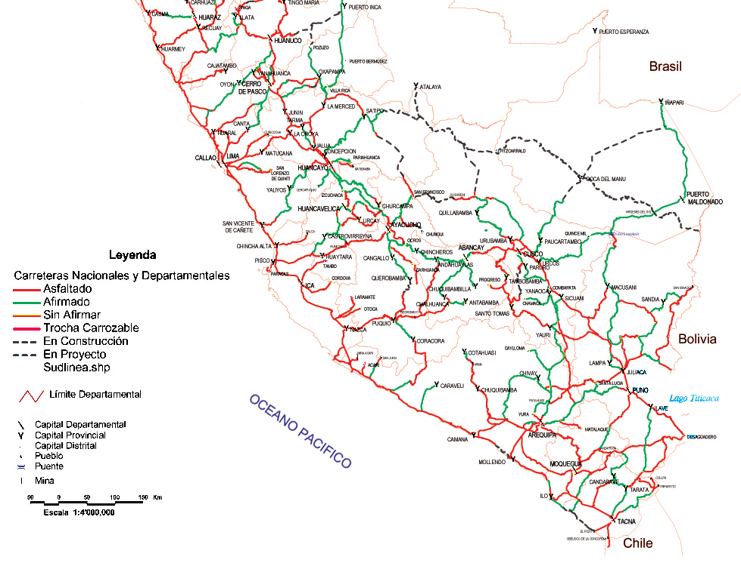

Figure 1: Route of transPeru Expedition, 1 July to 2 August, 2004

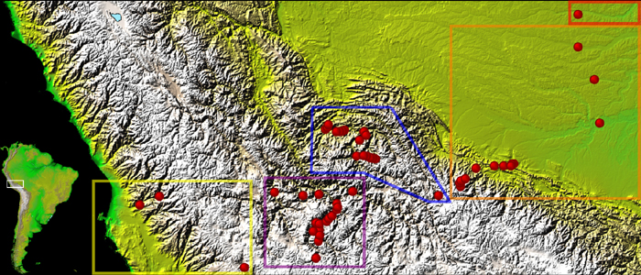

Figure 2: Map of 55 collecting sites in Pacific coast drainages (3 sites, 629-3199 m, yellow square), Apurimac Basin (18 sites, 1791-3999 m, magenta), Urubamba Basin (18, 560-3989 m, blue), Madre de Dios Basin (15, 164-2665 m, orange) and Purus Basin (1, 240 m, red).

